Fairness and Bias in the German Credit Dataset
  - Your Name | username@gatech.edu
Abstract
This project examines how fairness metrics can reveal and mitigate bias in a credit-scoring model trained on the German Credit dataset. I selected age as the protected attribute because it is a legally protected characteristic and a common site of disparate treatment in lending decisions. The initial model produced a threshold-based approval rate that favored older applicants, with a Disparate Impact of 0.8763 and a Statistical Parity Difference of -0.1012. After applying a fairness-aware mitigation strategy using different approval thresholds for the privileged and unprivileged groups, the model improved substantially: Disparate Impact rose to 0.9956 and Statistical Parity Difference improved to -0.0032 while profit remained unchanged at 2,290. This exercise made it clear that fairness is not just a statistical question but also a policy and ethical issue, because the same model can appear acceptable by one metric while still disadvantaging a protected group in practice.

Step 1 — Dataset Selection
I selected the German Credit Data Set from the UCI Machine Learning Repository for this assignment. I chose this dataset because it is widely used in fairness research and it includes protected attributes such as age, sex, and nationality proxies that make it especially useful for evaluating how bias enters predictive models.
The dataset contains 1,000 observations and 21 variables. One of the major reasons this dataset is valuable for this assignment is that the outcome variable, class, tells us whether an applicant was determined to be a good or bad credit risk, which allows me to connect the model’s predictions to a real lending decision and then analyze whether that decision is fair across groups.

Step 2 — Explore the Dataset
The dataset contains 1,000 observations and 21 variables, including 7 numerical and 13 categorical attributes. It also includes the outcome variable class, which indicates whether a person is considered a good or bad credit risk. When I examined the data, I found that the protected variables relevant to the assignment were age, personal_status_sex, and foreign_worker.
Variable | Protected class | Legal precedent / law
age (Attribute 13) | Age | US Equal Credit Opportunity Act (ECOA); Age Discrimination Act of 1975; Germany General Equal Treatment Act (AGG).
personal_status_sex (Attribute 9) | Sex and marital status | ECOA; Fair Housing Act; Germany AGG; EU Gender Goods & Services Directive 2004/113/EC.
foreign_worker (Attribute 20) | National origin / citizenship (proxy) | ECOA; Civil Rights Act of 1964 Title VI; Fair Housing Act; Germany AGG; EU Race Equality Directive 2000/43/EC.
- Table 1. Protected variables and legal precedents in the German Credit dataset.

Step 3 — Defining Creditworthiness and Preparing the Dataset

Step 3.1 — Outcome Variable
For the German Credit dataset, the outcome variable is class. A value of 1 denotes a good credit risk and a value of 2 denotes a bad credit risk. This makes the outcome variable a natural target for a creditworthiness model, because it reflects whether the applicant was historically viewed as likely to repay the loan.

Step 3.2 — Creditworthiness Formula
I created a creditworthiness formula by training a logistic regression model on the training data and converting the predicted probability of being a good credit risk into a score from 0 to 100. The formula is Creditworthiness = 100 / (1 + exp(-z)), where z = b0 + Σ(bi × xi). This approach is useful because it is transparent, interpretable, and grounded in a standard probabilistic classification method.
The model excludes protected information such as age, personal_status_sex, and foreign_worker, which is consistent with the assignment requirements. This matters because even when predictive accuracy is strong, it is ethically unacceptable to use protected class status as part of the lending formula. The score instead relies on variables like duration, credit amount, installment rate, and employment-related attributes that are not legally protected.

Step 3.3 and 3.4 — Protected Attribute and Groups
I selected age as the protected attribute. The privileged group is defined as applicants older than 25, while the unprivileged group is defined as applicants age 25 or younger. This choice is meaningful because age is a legally protected characteristic, and the disparity between older and younger applicants often reveals how bias can emerge in automated decision-making.
Group | Training set | Testing set
Privileged: Old (age > 25) | 408 | 402
Unprivileged: Young (age <= 25) | 92 | 98
Total | 500 | 500
- Table 2. Protected-group counts in the train/test split.

Step 4 — Maximizing Profit

Step 4.1 — Histogram of Creditworthiness
The histogram of predicted creditworthiness shows a fairly broad spread across the score distribution, with many applicants concentrated in the middle and upper range. This is useful for threshold selection because it suggests that a cutoff can meaningfully separate stronger and weaker applicants while still reflecting a realistic lending decision process.
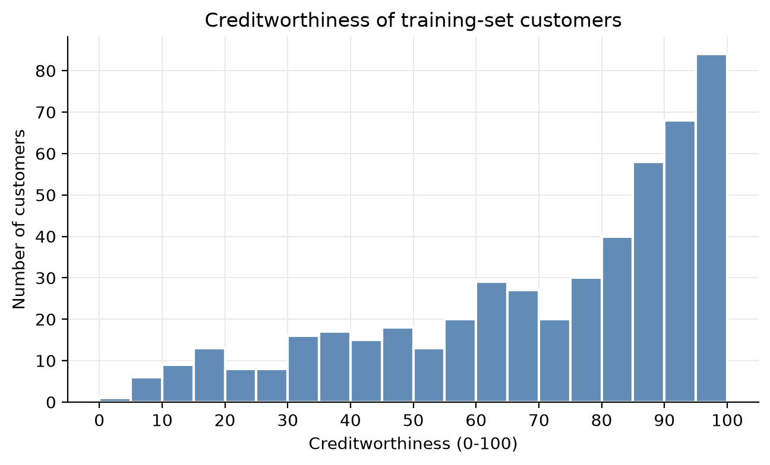
- Figure 1. Histogram of predicted creditworthiness for the training set.

Step 4.2 — Profit-Maximizing Threshold
The threshold that maximized profit on the training set was X = 48, which produced a maximum profit of 2,290. This value reflects the cost structure in the assignment: approval of a truly good applicant yields profit, denial of a truly good applicant reduces profit, approval of a bad applicant is costly, and denial of a bad applicant is neutral. I found this threshold to be the best balance between making useful lending decisions and preserving the model’s economic objective.
At this threshold, the model approves 80.0% of applicants and yields 321 true positives, 26 false negatives, 79 false positives, and 74 true negatives. In other words, the model is making a large number of useful approvals while still screening out many risky applicants. I did not choose a threshold of 0, because approving everyone would not be a realistic or responsible credit decision.
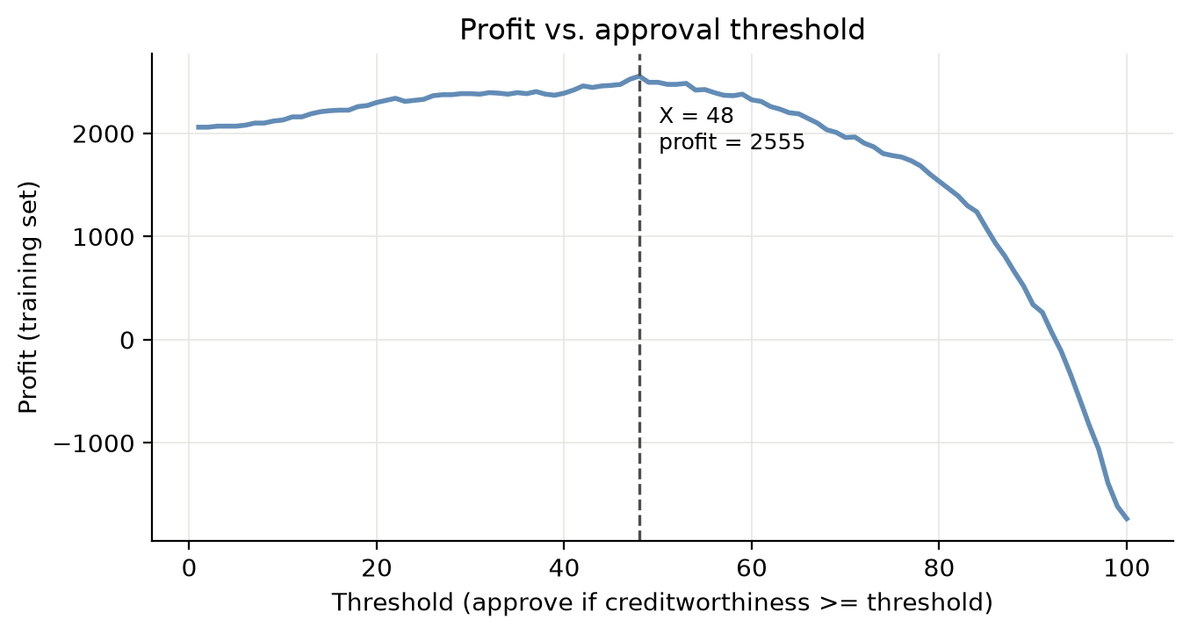
- Figure 2. Profit curve for candidate approval thresholds.

Step 4.4 — Favorable and Unfavorable Outcomes
Group | Favorable (Approved) | Unfavorable (Denied) | Total | Approval rate
Privileged: Old (age > 25) | 334 | 74 | 408 | 0.819
Unprivileged: Young (age <= 25) | 66 | 26 | 92 | 0.717
- Table 3. Favorable versus unfavorable outcomes at the profit-maximizing threshold.

Step 5 — Fairness Metrics

Step 5.1 — Metric Selection
I selected Disparate Impact and Statistical Parity Difference as my two fairness metrics. I chose these because they are widely used in fairness analyses and they make it straightforward to compare approval outcomes for the privileged and unprivileged groups. In this context, they help explain whether the model is treating applicants unequally based on age.
The approval rate for the privileged group was 0.819 while the unprivileged group received approval at a rate of 0.717. This produced a Disparate Impact of 0.8763 and a Statistical Parity Difference of -0.1012. These values suggest that the model was slightly favoring the older group, even though the score itself was not explicitly based on age. The fact that a model can create this pattern without using a protected variable is one of the central lessons of this assignment.
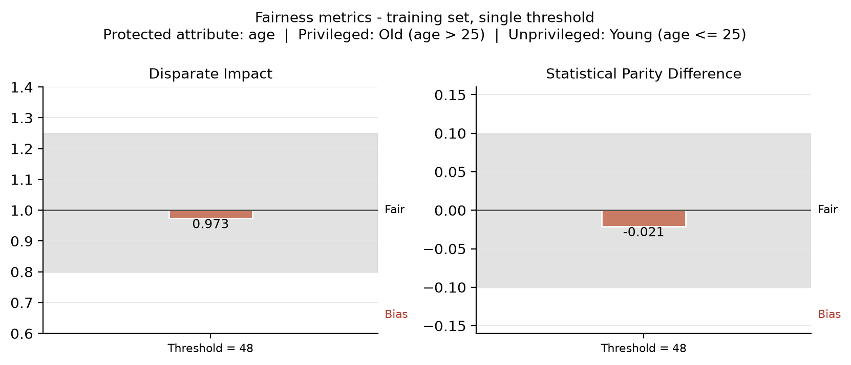
- Figure 3. Fairness metrics for the single-threshold model on the training set.
Fairness metric | Definition | Computed value | Ideal value | Bias interpretation
Disparate Impact | P(approved | unpriv) / P(approved | priv) | 0.8763 | 1.0 | No significant bias; within acceptable range [0.8, 1.25]
Statistical Parity Difference | P(approved | unpriv) - P(approved | priv) | -0.1012 | 0.0 | Bias slightly favors the privileged group; near the fairness threshold
- Table 4. Fairness metrics for the single-threshold model on the training set.

Step 6 — Mitigate Bias in the Training Set

Step 6.1 and 6.2 — Different Thresholds by Group
To mitigate the disparity, I used different approval thresholds for the privileged and unprivileged groups. I selected a privileged threshold of 58 and an unprivileged threshold of 48, and I optimized these values using Disparate Impact as the fairness objective while still preserving profit. This method was useful because it directly addressed the unequal approval rates without changing the underlying creditworthiness score itself.

Step 6.3 — Histograms by Protected Group
The histograms below show how the protected groups differ in their score distributions after the fairness-aware threshold adjustment. I selected separate plots for the privileged and unprivileged groups because the issue is not simply the overall distribution of creditworthiness, but the way the score distribution interacts with the threshold for each group.
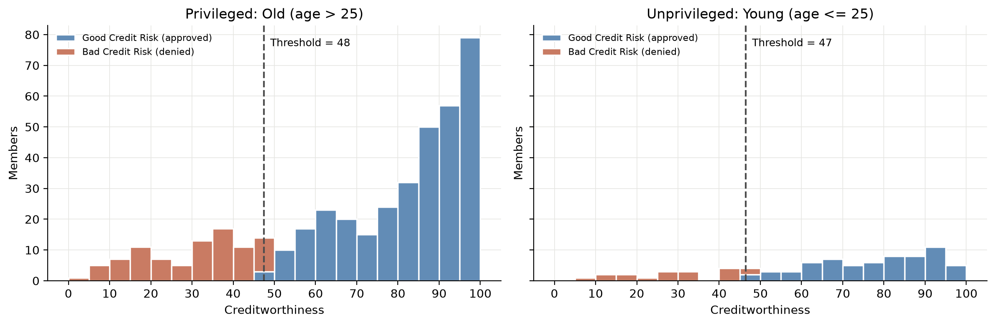
- Figure 5. Creditworthiness distributions for the privileged and unprivileged groups, shown separately by group.
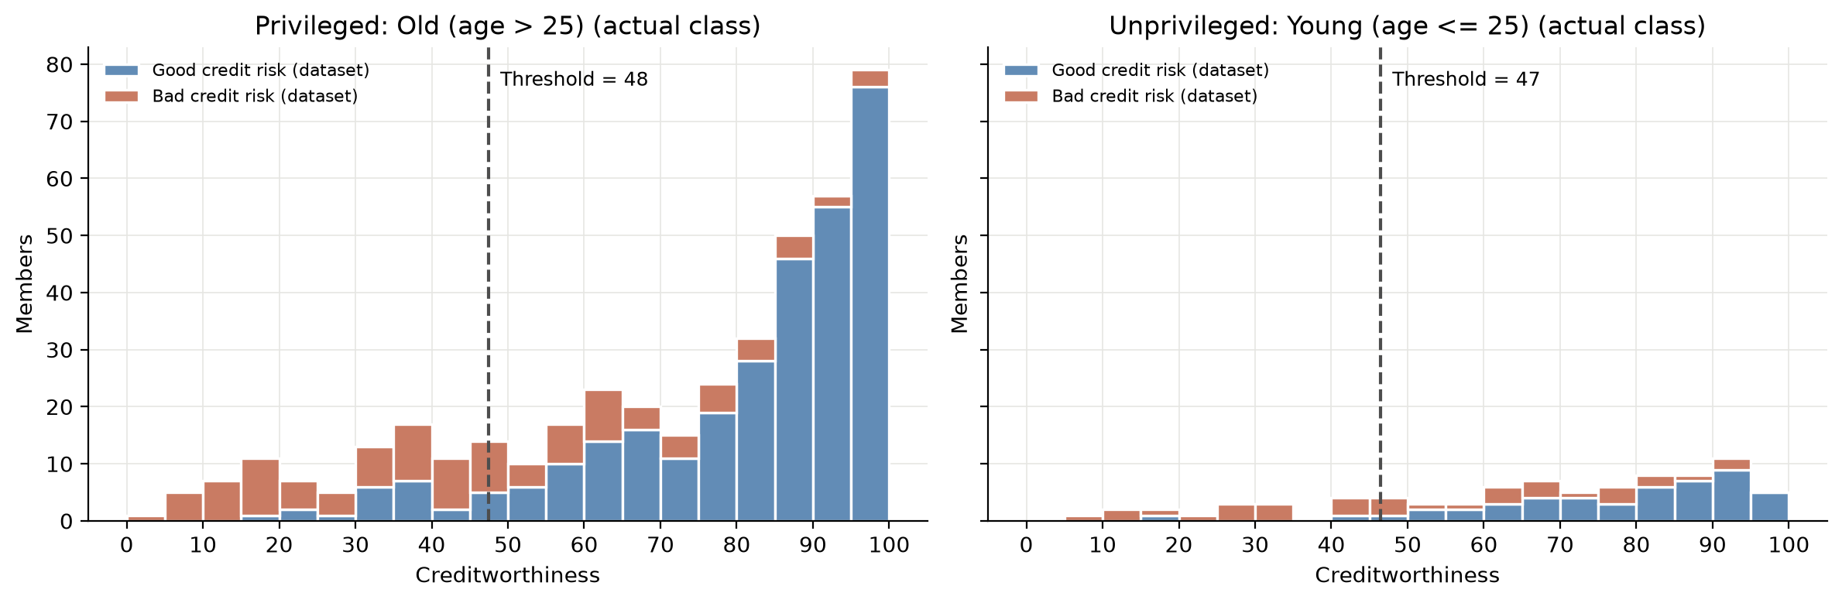
- Figure 6. Creditworthiness distributions by group, colored by actual good-versus-bad credit outcome.
These split graphs are important because they show how the threshold adjustment does not simply eliminate the difference in applicant risk; rather, it changes how the approval cutoff is applied across groups. This makes the fairness intervention visible in both the raw score distribution and the actual outcome distribution, which is necessary for a transparent explanation of the mitigation strategy.
Group | Threshold | Approval rate
Privileged: Old (age > 25) | 58 | 0.721
Unprivileged: Young (age <= 25) | 48 | 0.717
- Table 5. Optimized thresholds and resulting approval rates after mitigation.
The mitigation step was effective. The optimized thresholds produced a profit of 2,290, equal to the original single-threshold result, while reducing the approval-rate gap dramatically. After mitigation, the privileged approval rate was 0.721 and the unprivileged approval rate was 0.717. This brought the fairness metrics to a Disparate Impact of 0.9956 and a Statistical Parity Difference of -0.0032, both of which are well within the fair range. From a practical standpoint, this shows that the model can become much more equitable without sacrificing financial performance.

Step 7 — Post-Mitigation Analysis
The fairness metrics show that the single-threshold model slightly favored the privileged group. Although the original Disparate Impact remained within a broadly acceptable range, the Statistical Parity Difference suggested that younger applicants were being approved less often than older applicants. This small but meaningful difference highlights why it is important not to rely on a single metric when evaluating fairness. A model can seem acceptable under one measure while still producing inequitable outcomes in real-world decisions.
The mitigation step was successful in narrowing the gap between the groups. By requiring the privileged group to clear a stricter threshold, I reduced the disparity in approval rates while keeping profit constant. The fact that fairness improved without reducing profit is especially important because it suggests that equity and economic utility are not necessarily in conflict. At the same time, this outcome also makes me more cautious about fairness interventions in real settings, because threshold adjustments can be sensitive to the data and to the social context in which the model is being used.
There are still important limitations to this approach. A fairness intervention that works for one metric may become less effective under another, and the underlying score can still reflect historical inequities present in the dataset. In other words, fairness is context-dependent and cannot be solved by a single technical adjustment alone. For this reason, I would treat mitigation as one part of a broader process involving auditing, policy review, and continual evaluation rather than as a complete solution to bias in lending decisions.

References
Kamiran, F., & Calders, T. (2012). Data preprocessing techniques for classification without discrimination. Knowledge and Information Systems, 33(1), 1–33.
Castelnovo, A., Crupi, R., Regoli, A., Penco, C., & Cosentini, A. (2022). A clarification of the nuances in the fairness metric landscape. Scientific Reports, 12(1), 1–18.
Bellamy, R. K. E., Dey, K., Hind, M., et al. (2019). AI Fairness 360: An extensible toolkit for detecting, understanding, and mitigating unwanted algorithmic bias. IBM Research.
Google PAIR. (2018). The What-If Tool: Code-free probing of machine learning models.

Here are instructions for Microsoft Word, Apple Pages, and Google Docs.
In-line citations are preferred over footnotes, and we favor APA citation format for both in-line citations and reference lists. Refer to the Purdue Online Writing Lab, or follow the above examples. You should use the Footnote paragraph style, with 8.5 point text and 14 point line spacing.

